ECA - 5610 5G/6G Communication Systems
NAME : MOHIT V 192512043
EXP 7 Analog Beamforming Analysis Using MATLAB

Aim
To analyze the performance of analog beamforming by studying beamforming gain, beam width,
and main lobe direction using MATLAB.
Objectives
1. To analyze the beamforming gain achieved by varying the number of antenna elements in
an analog beamforming system using MATLAB.
2. To compare the beam width of an antenna array for different beamforming configurations
using MATLAB.
3. To analyze the main lobe direction by steering the antenna array beam to different angles
using MATLAB.
Software Required
• MATLAB
Theory
Analog beamforming is a beam steering technique in which a single RF chain drives multiple
antenna elements through adjustable phase shifters. By controlling the phase of the transmitted or
received signals, the antenna array forms a directional beam toward the intended user, thereby
improving signal strength, coverage, and spectral efficiency. Analog beamforming is widely
employed in millimeter-wave (mmWave) communication systems due to its reduced hardware
complexity and lower power consumption.
OUTPUT AND RESULT :
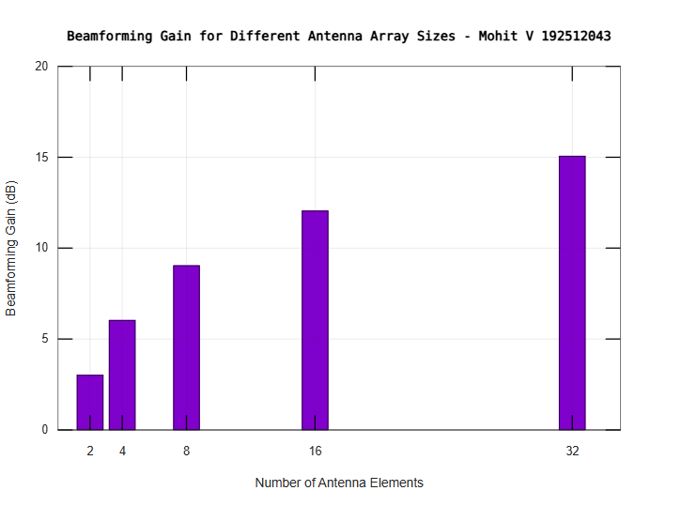
OBJECTIVE 1 :
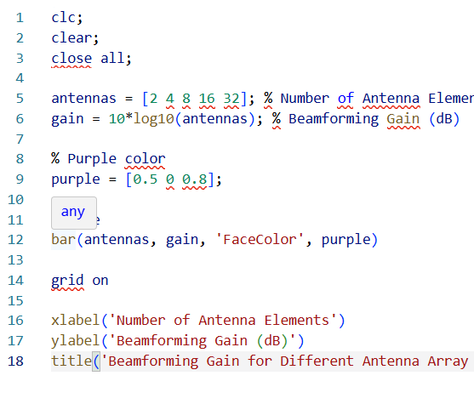

OBJECTIVE 2:
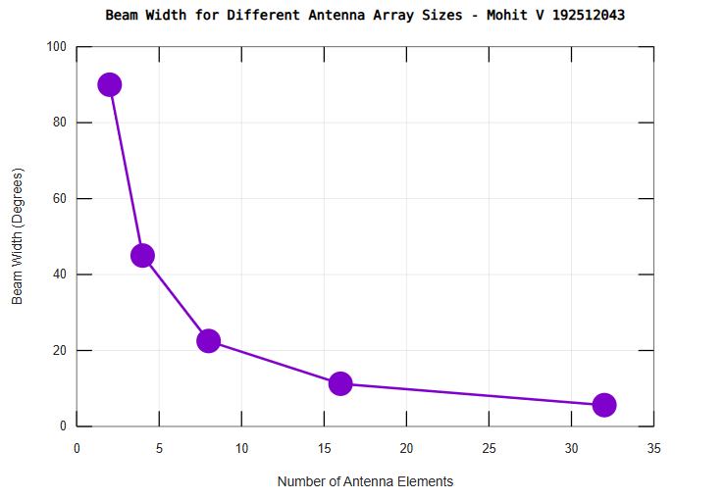
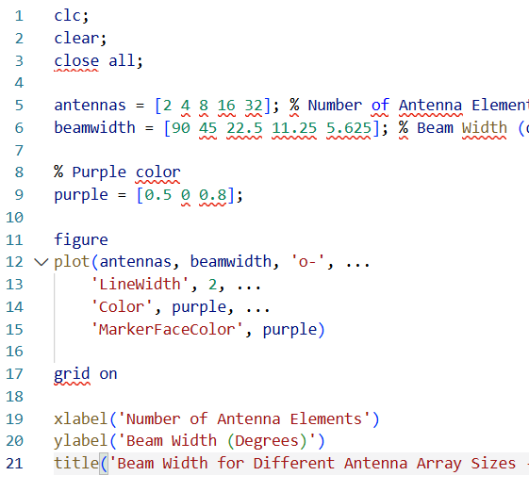

OBJECTIVE 3 :
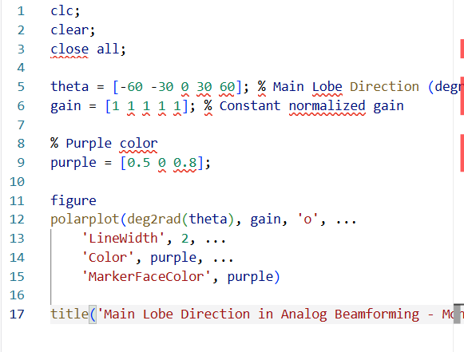
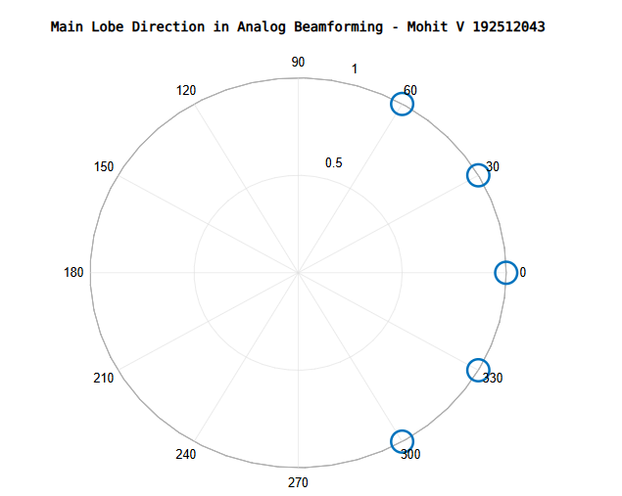

Result:
The MATLAB analysis successfully demonstrated the characteristics of analog beamforming. The results showed that increasing the number of antenna elements improves beamforming gain and reduces beam width, while phase adjustment enables the main lobe to be steered toward different directions.

